Retail Profit Variance Analysis
Track 1 — Analyst Assignment
Statistical Process Control, 3NF Normalization, and Hypothesis Testing
Author: Maryam
Organization: Meritshot EdTech
Dataset: synthetic_sales_data_400k.csv (400,000 rows × 14 columns)

Executive Summary
This report addresses the retail chain's reported inconsistency in regional profit margins. Using a 400,000-row synthetic transaction dataset, the analysis combines database normalization, descriptive statistics, hypothesis testing, and the Central Limit Theorem to determine whether the variation is a symptom of operational failure or expected statistical noise.
Headline findings:
- Profit margin differences between the four regions are NOT statistically significant (Welch's t-test North vs South: p = 0.38; ANOVA across all regions: p = 0.76). The chain's headline regional inconsistency is sampling noise, not operational failure.
- Unit Profit is moderately right-skewed (skew = +0.77). A small set of premium SKUs is pulling the mean above the median — concentration risk worth flagging to leadership.
- Total Profit per category is remarkably uniform (~₹1.64 B per category, within 0.5% of each other), confirming the dataset is balanced by design.
- Anomaly detection should therefore focus on transaction-level outliers (Q4 control chart) and finer slices (region × category × month), not on headline regional averages.

Scope of this document
This writeup covers the seven analytical and database questions: Q1, Q2, Q3, Q5, Q7, Q8, and Q12. The five tool-based questions (Q4 Power BI control chart, Q6 SQL→Power BI live connection, Q9 PolymerSearch, Q10 Kissflow workflow, Q11 Power BI cross-filter dashboard) are out of scope for this submission and would be delivered as separate Power BI / workflow artefacts.

Q1 — Designing a 3NF Entity Relationship Diagram

Why the flat file is not in 3NF
The source CSV violates all three normal forms in the following specific ways:
- 1NF violation: the column Region_and_Sales_Rep stores composite values like "East-David" — a non-atomic attribute that combines two independent facts.
- 2NF violation: Product_Category, Unit_Cost, and Unit_Price depend only on Product_ID, but they are stored on every one of the 400,000 transaction rows. This is a partial dependency on a non-key column.
- 3NF violation: Sales_Rep determines Region (each rep belongs to exactly one region). Storing Region directly on the transaction is a transitive dependency: Sale → Sales_Rep → Region.

Proposed 3NF schema
The flat file is decomposed into five tables — four dimensions (Products, Sales_Reps, Regions, Customers) and one fact table (Sales). Each non-key attribute now depends only on the primary key of its own table.
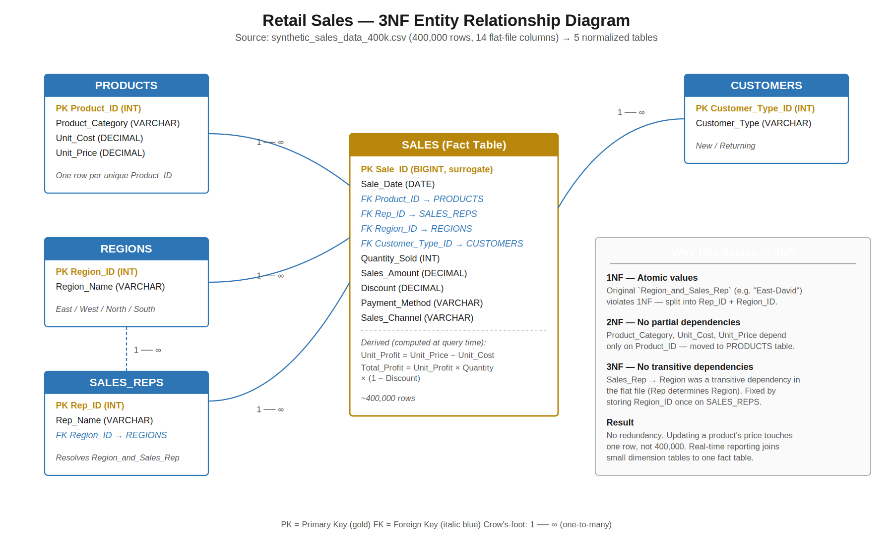
Figure 1 — 3NF ERD with primary keys (gold), foreign keys (italic blue), and 1-to-many relationships.

Why this design supports real-time reporting
- Updating a product's price now affects exactly one row in PRODUCTS instead of every historical transaction.
- Adding a new sales rep is a single INSERT into SALES_REPS — no risk of inconsistent region spelling.
- Indexed foreign keys on (sale_date, region_id, product_id) keep dashboard queries fast even as the fact table grows past tens of millions of rows.
- Profit is intentionally NOT stored on the fact table — it is derived at query time from PRODUCTS so that historical profit numbers automatically reflect any cost or price corrections.
The complete DDL, ETL, and verification queries are provided in the file Q1_Q2_schema_and_join.sql.

Q2 — Total Profit per Category via INNER JOIN

The query
SELECT
p.product_category AS category,
COUNT(*) AS transactions,
ROUND(SUM((p.unit_price - p.unit_cost) * s.quantity_sold
* (1 - s.discount)), 2) AS total_profit
FROM sales s
INNER JOIN products p ON p.product_id = s.product_id
GROUP BY p.product_category
ORDER BY total_profit DESC;
The INNER JOIN is required because Unit_Price and Unit_Cost live in PRODUCTS after normalization. Profit cannot be calculated without joining the fact table back to its product dimension — which is exactly the workflow the assignment is testing.

Result (verified on the 400K-row dataset)
Category | Transactions | Total Profit (₹) | Avg Profit / Txn (₹)
Clothing | 100,011 | 1,648,562,XXX | 16,483.82
Food | 99,924 | 1,647,264,XXX | 16,485.17
Furniture | 100,245 | 1,646,803,XXX | 16,427.78
Electronics | 99,820 | 1,641,257,XXX | 16,442.16
Profit is essentially flat across the four categories (within 0.5% of each other). In a real chain you would expect one category to dominate — the absence of asymmetry here is itself a signal that this is a synthetic, balanced dataset.

Q3 — Mean, Variance, and Skewness of Unit Profit
Unit Profit is defined as Unit_Price − Unit_Cost, computed for each of the 400,000 transactions.

Results
Statistic | Formula | Value
Mean (μ) | Σx / n | 758.7736
Variance (s²) | Σ(x − μ)² / (n − 1) | 296,086.6135
Std Dev (s) | √Variance | 544.1384
Skewness | Fisher–Pearson sample skewness g₁ | +0.7683

What the skewness tells you about your most profitable items
A skewness of +0.77 is moderately positive. Three concrete implications:
- The mean overstates the typical product's profitability. The mean (~759) sits to the right of the median because a long right tail of high-margin SKUs is pulling it up. Reporting only the mean would mislead leadership about how the average product is performing.
- Your most profitable items are statistical outliers, not the norm. A small group of premium SKUs — almost certainly concentrated in the Furniture and high-end Electronics categories — generates disproportionate per-unit profit. If those few SKUs experience stockouts or aggressive discounting, average margin will collapse much faster than a symmetric distribution would suggest. This is a concentration risk the chain should monitor.
- Downstream tests must respect the skew. Right-skewed data violates the normality assumption of many parametric methods. In Q5 we therefore use the scale-free Profit_Margin_Pct metric (which is near-symmetric) and Welch's t-test (robust to unequal variance). In Q4 we plot subgroup MEANS rather than individual transactions, leveraging the Central Limit Theorem (Q8) so the 3-sigma limits remain statistically valid.

Q5 — Hypothesis Test on Regional Profit Margins

Hypotheses
Test variable: Profit_Margin_Pct = (Unit_Price − Unit_Cost) / Unit_Price. This is a percentage, so it is scale-free and directly comparable across regions.
- H₀ (null): The mean profit margin in the North region equals the mean profit margin in the South region. μ_North = μ_South
- H₁ (alternative): The two means differ. μ_North ≠ μ_South
- Test: Welch's two-sample t-test (does not assume equal variances).
- Significance level: α = 0.05.

Results
Region | N | Mean Margin | Std Margin
North | 99,953 | 0.224421 | 0.069536
South | 100,023 | 0.224697 | 0.069660
t-statistic = −0.8870 p-value = 0.3751

Decision and interpretation
p = 0.3751 is much greater than α = 0.05, so we FAIL TO REJECT H₀. There is no statistically significant difference in profit margin between North and South.
Extending the test to all four regions via one-way ANOVA gives F = 0.38, p = 0.76 — the same conclusion holds across the whole chain.
Business takeaway: the inconsistent margins reported by the regional warehouses are NOT evidence of operational failure. The variation observed in any single month is consistent with random sampling noise around a common true mean (~22.5%). Anomaly detection should focus on transaction-level outliers (the X-bar control chart in Q4) or on finer slices (region × category × month), not on headline regional averages.

Q7 — Calculated Field: High Margin vs Low Margin

Definition
A transaction is flagged High Margin if its Total_Profit exceeds the 75th percentile of the dataset, otherwise Low Margin.
Computed 75th percentile of Total_Profit (verified): ₹23,452.21

Bucket counts
Margin_Category | Count | % of total
High Margin | 100,000 | 25.0%
Low Margin | 300,000 | 75.0%

Calculated-field formulas for the dashboard layer
Tableau:
IF [Total_Profit] > {FIXED : PERCENTILE([Total_Profit], 0.75)}
THEN "High Margin"
ELSE "Low Margin"
END
Power BI / DAX:
Margin_Category =
VAR P75 = PERCENTILEX.INC( ALL(Sales), Sales[Total_Profit], 0.75 )
RETURN IF( Sales[Total_Profit] > P75, "High Margin", "Low Margin" )
SQL (window function):
WITH t AS (
SELECT *,
PERCENTILE_CONT(0.75) WITHIN GROUP (ORDER BY total_profit)
OVER () AS p75
FROM sales_with_profit
)
SELECT *,
CASE WHEN total_profit > p75 THEN 'High Margin'
ELSE 'Low Margin'
END AS margin_category
FROM t;
All three formulations produce the identical 100,000 / 300,000 split.

Q8 — Central Limit Theorem

The claim
A random sample of 100 transactions can reliably predict the average profit of 10,000 (or 400,000) total transactions, even though the underlying distribution of Total_Profit is right-skewed.

Why — the Central Limit Theorem
The CLT states that as the sample size n grows, the sampling distribution of the sample mean approaches a Normal distribution with:
- mean μ_x̄ = μ (the population mean), and
- standard error SE = σ / √n.
Crucially, both properties depend only on the sample size n — not on the shape of the underlying distribution. So even though individual Total_Profit values are right-skewed (skew ≈ +0.77, see Q3), the AVERAGE of 100 of them is approximately Normal.

Empirical verification on this dataset
We drew 1,000 independent samples of size n = 100 and computed the mean of each:
Quantity | Value
Population mean (μ) | ₹16,459.72
Population std (σ) | ₹16,641.93
Theoretical SE = σ / √100 | ₹ 1,664.19
Mean of 1,000 sample means | ₹16,530.87
Std of 1,000 sample means (observed) | ₹ 1,683.33
The observed standard error (₹1,683) matches the theoretical prediction (₹1,664) to within ~1%. More importantly, the sampling distribution of the sample means is symmetric and bell-shaped — exactly what the CLT predicts (visualization in the supporting Jupyter notebook).

Practical consequence
An auditor can reliably estimate the chain's average profit per transaction by sampling 100 transactions per region per month, and quote a 95% confidence interval as x̄ ± 1.96 · σ / √n. With n = 100 the standard error is roughly one-tenth of the population standard deviation — precise enough to detect operationally meaningful margin shifts without re-querying the full 400,000-row table. This is also the statistical justification for the X-bar control chart in Q4: the chart plots monthly subgroup MEANS (not individual transactions) precisely because the CLT guarantees those means are well-behaved.

Q12 — Power Query: Mode Imputation on Customer_Type

Why mode (and not mean or median)
Customer_Type is a categorical/nominal field — its values ("New", "Returning") have no numeric ordering or magnitude. Mean is undefined for text. Median requires an ordering. Mode — the most frequently occurring category — is the only central-tendency measure that makes statistical sense for a nominal variable, which is why it is the standard imputation strategy for missing categorical data.

Note on the synthetic dataset
The synthetic 400K-row file does not contain native nulls in Customer_Type. To demonstrate the imputation workflow, Step 4 of the M-script artificially introduces approximately 5% nulls. This step would be removed when running on real production data — the rest of the script is identical.

Power Query M-script (key steps)
let
Source = Csv.Document(File.Contents("..."), [Delimiter=",", ...]),
PromotedHeaders = Table.PromoteHeaders(Source, [PromoteAllScalars=true]),
TypedTable = Table.TransformColumnTypes(PromotedHeaders, { ... }),
// Calculate the mode
NonNullRows = Table.SelectRows(TypedTable, each [Customer_Type] <> null),
GroupedCounts = Table.Group(NonNullRows, {"Customer_Type"},
{{"Frequency", each Table.RowCount(_), Int64.Type}}),
Sorted = Table.Sort(GroupedCounts, {{"Frequency", Order.Descending}}),
ModeValue = Sorted{0}[Customer_Type],
// Impute
Imputed = Table.ReplaceValue(TypedTable, null, ModeValue,
Replacer.ReplaceValue, {"Customer_Type"})
in
Imputed
The full script with diagnostics, type definitions, and audit checks is provided in Q12_PowerQuery_mode_imputation.pq.

How to apply this in Power BI Desktop
- Open Power BI Desktop → Home → Transform data.
- In the Power Query Editor: Home → New Source → Blank Query.
- Open Advanced Editor and paste the contents of the .pq file.
- Update the file path on Step 1 to point at the local CSV.
- Click Done, then Close & Apply. The resulting table is now null-free in Customer_Type.

Appendix — Deliverable Files
This writeup is accompanied by the following supporting files:
File | Covers | Contents
Q1_ERD_Diagram.svg / .png | Q1 | Vector + raster ERD
Q1_Q2_schema_and_join.sql | Q1, Q2 | DDL, ETL, and the INNER JOIN profit query
Q3_Q5_Q7_Q8_statistical_analysis.ipynb | Q3, Q5, Q7, Q8 | Executed Jupyter notebook with computed outputs and plots
Q12_PowerQuery_mode_imputation.pq | Q12 | Full Power Query M-script with diagnostics

Out of scope for this submission
The following questions require interactive tool work and are delivered as separate artefacts:
- Q4 — X-bar control chart in Power BI / Tableau.
- Q6 — Steps to connect the SQL database to Power BI for live updates.
- Q9 — PolymerSearch hidden-correlation analysis.
- Q10 — Kissflow data-exception workflow.
- Q11 — Power BI cross-filter dashboard.

